**Developing packages & plugins**

[14 - Packages & plugins](https://lexmarkad.sharepoint.com/:p:/r/sites/lexmark_mobile_solutions/_layouts/15/Doc.aspx?sourcedoc=%7B58B0CDF5-7DFD-490D-A9AF-1ED3142E16F7%7D&file=14%20-%20Packages%20%26%20plugins.pptx&action=edit&mobileredirect=true)

1. Create a Flutter Plugin project

flutter create --template=plugin --platform=ios,android <name\_folder>

1. Implement the interface (FoT)
   1. Implement the platform\_interface.dart

{required String title, required String nessage}) 
throw nas nat been implemented. • ) 

1. Implement the method\_channel.dart

@override 
showAtertDia10g( 
{required String title, required String message 
return await ' sh 
'title' : title, 
'message' : message, 

1. Implement the dart created file

showAIertDiaIog( 
(reauired String title, required String message}) 4 
return AlertPtuginPIatfor•.instonce 
.showAtertDiaIog(titIe: title, message: message) 

1. Implement the native code (NoT)
   1. Android
      1. Find **android** folder and right click on it. Open this module in Android Studio to mainly focus on the Android part.

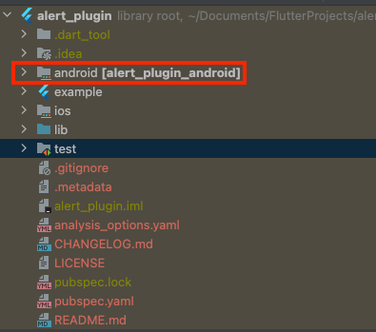

1. Open the app (AlertPlugin.kt) and add the functionality using native code

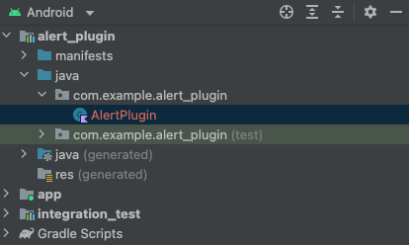

1. Extend from ActivityAware to get the activity





override fun 
Ghan.ng.l. sethethodcatuandler(null) 
override fun onAttaChedTOACtiVity(binding: 
qu.r.en.tAq.tXxX.W binding. 
binding: 
Activity pug in ainding) 
override fun 
override fun 
onOetaChedFronACtiVityForConfigCharvges() { 
onReattaChedTOACtiVityForConfigCharvges 
ActivityP1_ugin8inding) 
qu.r.en.tAq.tXxX.W binding. o 
override fun 
onDetachedFronACtiVity() 

override fun call. 
when (catt.method) 
•getPLatfarmVersion" 
, @NcnuoL1 result. 
• Resort) 
result. success( "Android ${android.os.Bui1d. VERSION. RELEASEY') 
•snowmertoialag" 
val. args catt.arguments as? Yap«String, 
return 1 
Any, 
val title args? as String? 
val message args? as String? 
val builder AlertDiaIog. 8uitder(a:) 
builder .setTitIe(titte P: 
•Title Default") 
builder 7: "Message Default") 
.setPositiveButton(android.R. string.aR) { _ 
result. success (true) 
builder . create() . show() 
7: •current activity null", "Can not snow dialog because current activity is null. 

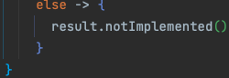

1. iOS
   1. Same with Android above, open iOS using Swift
   2. Open **ios > Classes > AlertPlugin.swift**
   3. Add the implementation

1. Try to test the created plugin
   1. Open main.dart

1. Add created alert dialog

@override 
Widget build(8uiIdContext context) { 
n Materiaupp( 
hone: Scaffold ( 
app8ar•: Appear ( 
• const Text ( •plugin 
title. 
// Aop8ar 
body: Center ( 
child: 
floatingACtionButton: FloatingACtåonButton( 
onPr•eSSed: _Sho•AIert. 
const 
// Nateriaupg 

_ShowAIert() 
try 
title: 
n Platfor 
_aLertPLugin. showA1ertJiaLog( 
'Native a 
catch (e) { 

**TAKE NOTE:**

alert_vtugin: 
men depending on this øockoge fran a reoc 
appzication gau should use: 
oZert_oLugin: "x.g.z 
See 
The OOP i S bundZed with the 
so we use a path dependency 
to use the Current pZugån's version. 